CHAPTER 1
INTRODUCTION
Audio signal processing, sometimes referred to as audio processing, is the intentional alteration of auditory signals or sound, often through an audio effect or effects unit. As audio signals may be electronically represented in either digital or analogue format, signal processing may occur in either domain. Analogue processors operate directly on the electrical signal, while digital processors operate mathematically on the digital representation of that signal.
1.1 Motivation
Digital audio is the name for the entire technology of sound recording and reproduction using audio signals that have been encoded in digital form. Digital audio technologies are used in the recording, manipulation, mass-production, and distribution of sound, including recordings of songs, instrumental pieces, podcasts, sound effects etc. Modern online music distribution depends on digital recording and data compression. The availability of music as data files, rather than as physical objects, has significantly reduced the costs of distribution. Analogue audio signals are susceptible to noise and distortion, due to the innate characteristics of electronic circuits and associated devices. Disturbances in a digital system do not result in error unless the disturbance is so large as to result in a symbol being misinterpreted as another symbol or disturb the sequence of symbols. It is therefore generally possible to have an entirely error-free digital audio system in which no noise or distortion is introduced between conversion to digital format, and conversion back to analogue. It is also difficult for music enthusiast community to invest in creating their own music since the music studios are extremely overpriced. A digital audio signal may optionally be encoded for correction of any errors that might occur in the storage or transmission of the signal. The aforementioned factors are paramount in establishing the role of DSP in the ever surging domain of audio effects. It is therefore highly advantageous to introduce the desired audio effects in the digital format after its conversion from the innate analogue signal in order to achieve error-free distortion-less DAFx synthesis.
1.2 Objective of the project
The mini-project aims to synthesize and demonstrate various digital audio effects such as delay, echo, reverberation, guitar distortion, stutter, feedback delay etc., simulating them at first using Scilab tool to visualize the nature of effect and then actualizing them on the Teensy 3.2 microcontroller using Teensy audio library. The system is intended to process the signals in real time for three modes of input, a microphone, a track stored in SD card and common signals like sinusoid, sawtooth, pulse etc,. Thereby realizing a complete DAFx synthesizer that is much demanded in the audio processing industry.

1.3 Organization of the report
The report is divided into 8 chapters. Chapter 2 begins by presenting theory of audio processing discussing several digital audio effects in detail, mentioning their expressions and the required tools to implement them. Chapter 3 goes on to depicting the block diagram of the complete system and each module. It gives a bird's eye view of the project depicting the three different modules. Chapter 4 explains the working and flow of module 1. Chapter 5 depicts the working of module 2 and chapter 6 explains the working of module 3 of the project. Chapter 7 draws conclusions on the result followed by the future work possible in this direction.

CHAPTER 2
LITERATURE REVIEW
Digital real time audio effects as of today are realized in software in almost all cases. The hardware platforms used for this purpose reach from multipurpose processors like the Intel Pentium class over embedded processors (e.g. the ARM family) to specialized DSP [1]. Since 2015, Teensy family of microcontrollers have come into picture since they are more versatile and easy to work with. Details of Teensy 3.2 are given in Appendix A. Basic audio effects are described below.
2.1 Echo
To simulate the effect of reverberation in a large hall or cavern, one or several delayed signals are added to the original signal. To be perceived as echo, the delay has to be of order 35 milliseconds or above. Short of actually playing a sound in the desired environment, the effect of echo can be implemented using either digital or analog methods. Analog echo effects are implemented using tape delays and/or spring reverbs. When large numbers of delayed signals are mixed over several seconds, the resulting sound has the effect of being presented in a large room, and it is more commonly called reverberation or reverb for short [2]. Ideally, echo can be described by the equation
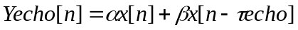 (2.1)
where, 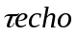 is the length of the echo , α and β are constants.

2.2 Flanger
To create an unusual sound, a delayed signal is added to the original signal with a continuously variable delay (usually smaller than 10 ms). This effect is now done electronically using DSP, but originally the effect was created by playing the same recording on two synchronized tape players, and then mixing the signals together. As long as the machines were synchronized, the mix would sound more-or-less normal, but if the operator placed his finger on the flange of one of the players (hence flanger) , that machine would slow down and its signal would fall out-of-phase with its partner, producing a phasing effect. Once the operator took his finger off, the player would speed up until its tachometer was back in phase with the master, and as this happened, the phasing effect would appear to slide up the frequency spectrum. This phasing up-and-down the register can be performed rhythmically [2].

2.3 Phaser
Another way of creating an unusual sound. The signal is split, a portion is filtered with an all-pass filter to produce a phase-shift, and then the unfiltered and filtered signals are mixed. The phaser effect was originally a simpler implementation of the flanger effect since delays were difficult to implement with analog equipment. Phasers are often used to give a "synthesized" or electronic effect to natural sounds, such as human speech. The voice of the character C-3PO from Star Wars was created by taking the actor's voice and treating it with a phaser [2].

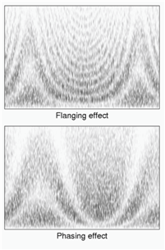
Figure 2.1 Spectrograms of flanging and phasing effects [2]
2.4 Chorus
A delayed signal is added to the original signal with a constant delay. The delay has to be short in order not to be perceived as echo, but above 5 ms to be audible. If the delay is too short, it will destructively interfere with the un-delayed signal and create a flanging effect. Often, the delayed signals will be slightly pitch shifted to more realistically convey the effect of multiple voices [2].

2.5 Echo Cancellation
Echo suppression and echo cancellation are methods used in telephony to improve voice quality by preventing echo from being created or removing it after it is already present. In addition to improving subjective audio quality, echo suppression increases the capacity achieved through silence suppression by preventing echo from traveling across a network [1].

2.6 Reverberation
Reverberation, in acoustics, is a persistence of sound after the sound is produced. A reverberation, is created when a sound or signal is reflected causing a large number of reflections to build up and then decay as the sound is absorbed by the surfaces of objects in the space. This is most noticeable when the sound source stops but the reflections continue, decreasing in amplitude, until they reach zero amplitude. The reverberation of a listening space is typically characterized by three distinct time periods: the direct sound, the early reflections, and the late reflections. The early reflections correspond to the first few reflections off the walls of the room. As the waves continue to bounce off the walls, their density increases and they disperse, arriving at the listener from all directions. This is the late reflection part. A plain reverberator is used as an elementary building block to build on complicated reverberation algorithms[3]. Artificial reverberation is an unusually interesting signal processing problem because, the obvious methods based on physical modelling or input-output modeling are too expensive computationally for most applications. Thus, DSP techniques are sought to induce reverberation effects [4].
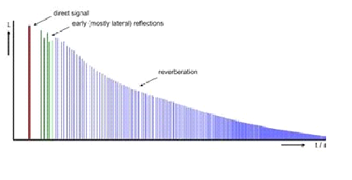
Figure 2.2 Frequency response of induced reverberation [ 4]

2.7 Wah-wah
Wah-wah is an onomatopoeia for the sound of altering the resonance of musical notes to extend expressiveness, sounding much like a human voice saying the syllable wah. The wah- wah effect is a spectral glide accomplishing modification of the vowel quality of a tone. The wah-wah effect is produced by periodically bringing in and out of play treble frequencies while a note is sustained. In technical parlance, the wah-wah effect describes a time-varying band pass filter. In this case the concept of a second-order all pass filter is to be realized. The idea is to create an all pass filter with phase shifting by 360 degrees. The filtered signal has to be subtracted from the original signal. When this elementary operation is done an all pass behavior results instead of a band pass (BP) behavior. Analogue to this fact, we can add the original signal to the filtered signal producing in effect a band-reject filter [1].
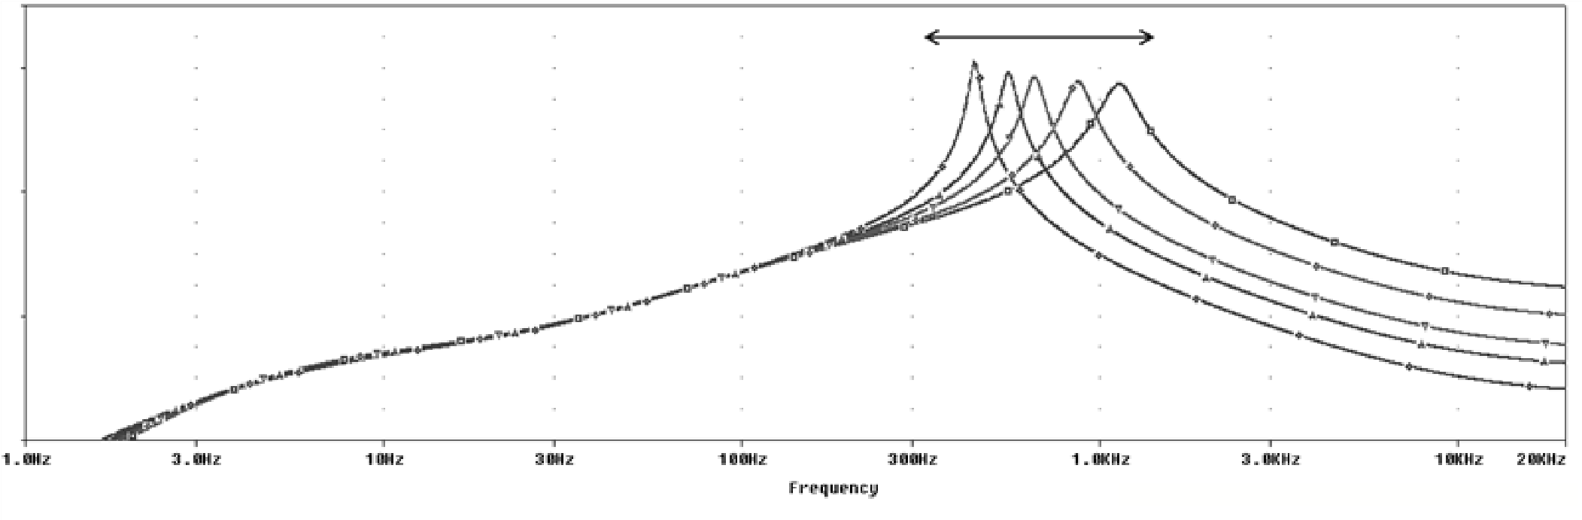
Figure 2.3 Wah-wah effect in frequency domain [1]
2.8 Delay
Delay is an audio effect and an effects unit which records an input signal to an audio storage medium, and then plays it back after a period of time. The delayed signal may either be played back multiple times, or played back into the recording again, to create the sound of a repeating, decaying echo. Delay effects range from a subtle echo effect to a pronounced blending of previous sounds with new sounds. Depending on delay time the effect has different names because of the particular character of the resulting sound. If the delay is in the range between 10 and 25 ms, we will hear a quick repetition named slap back or doubling. If the delay is greater than 50 ms we will hear an echo. One can use a single hardware unit for both of these delay based effects while the splitting into two different effects can be done in software [2].
MIDI and synthesizers are an integral part of audio processing. Musical Interface Digital Instrument is a way to connect devices that make and control sound. MIDI was meant to allow someone to control multiple synthesizers from a single keyboard [5]. Now MIDI standards are used for sequencing software for personal computers to let users record, store and edit music, as well as manage large collections of synthesizer sounds [6].

CHAPTER 3
BLOCK DIAGRAM
The project consists of 3 main systems. The Teensy controller and three modules which are real time system taking microphone as input, MIDI and Synthesizer. The overall block diagram of the entire project inclusive to the above mentioned modules are shown in Figure 3.1.

Teensy 3.2 board with audio shield

MODULE 1

MODULE 2

MODULE 3

Array of push buttons
D0 to D7
Array of push buttons
A0 to A3
Joystick

Switch

Analog Pot
Reaper software
2 Analog Pots

Figure 3.1 Block diagram of the complete system
3.1 Creating simple audio system using Teensy 3.2
3.1.1 Simple delay
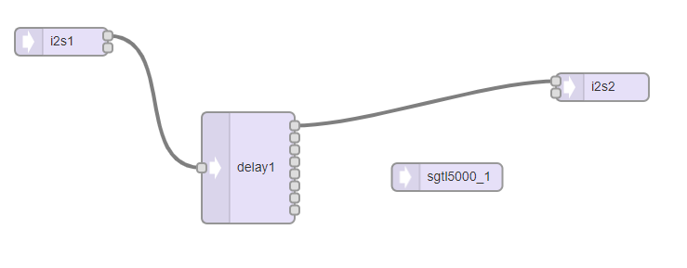
Figure 3.2 Block diagram of simple delay effect

Simple delay is an effect of repeating the same audio after an interval of time. The expression is given by
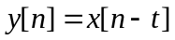 (3.1)
where is the amount of delay introduced.
Here, the input sound is obtained from the microphone (i2s1) on the Teensy audio shield. This is delayed by an interval of 400ms. The delayed sound is sent to the output speaker (i2s2). SGTL5000 is the audio codec on the teensy audio shield which assigns microphone as the input [7].

3.1.2 Feedback (Echo) delay
Feedback delay is an audio effect in which the delayed input signal is added with the original input signal which is again delayed and added with the original input using as feedback loop. The amount of echoes produced depends on the value of the gain of output given by the mixer.
The expression is given by
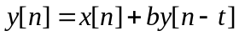 (3.2)
where 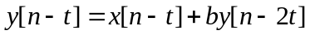 (3.3)
is the amount of delay
is the mixer gain.
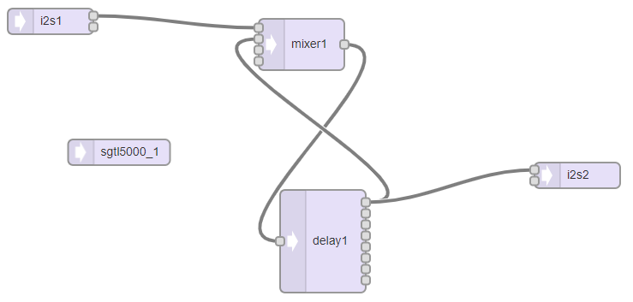
Figure 3.3 Block diagram of feedback delay

The input signal is obtained from the microphone (i2s1). The mixer gain (b) is equal to 0.7 which implies that the signal is being attenuated. The amount of delay is 400ms. The output is given to the speaker (i2s2).

3.2 Module 1: Real time audio system taking input from microphone
The module produces two audio effects which are 'guitar distortion' and 'reverberation'. A switch is used to toggle between the two effects. A joystick is used to control the amount of effect.
3.2.1 Guitar distortion
Distortion audio effect is the name associated with the iconic steel- grunge sound emanating from an electric guitar. This can be produced by wave clipping. It can be synthesized digitally by bit crushing and reducing the sampling rate of the audio input. The bit crusher effect is a predefined function in the Teensy audio library [7].
Figure 3.4 shows the block diagram of the guitar distortion effect.
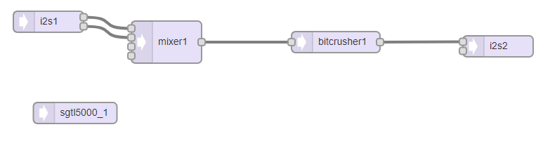
Figure 3.4 Block diagram of guitar distortion effect

The input obtained from the microphone is sent to mixer where both the left and right channels of the input are added. This signal is sent to the bit crusher block. This block has two functions. It reduces the bit depth and also the sampling rate of the 16 bit signal source resulting in distorted sound. The amount of distortion is controlled by the values obtained from the 2-axis joystick. The optimum distortion sound is obtained when the number of bits crushed is 10 (LSB) and the sampling rate is 2000 Hz.

3.2.2 Reverberation
It occurs when there is discrepancy delay between sound waves heard by a point receiver. It is a result of sound waves reflected off surrounding objects. For the effect, it is necessary to design and audio loop containing several delay tap lines. Each delay tap line represents a distinct echo returning to the ear of the observer [8][9].
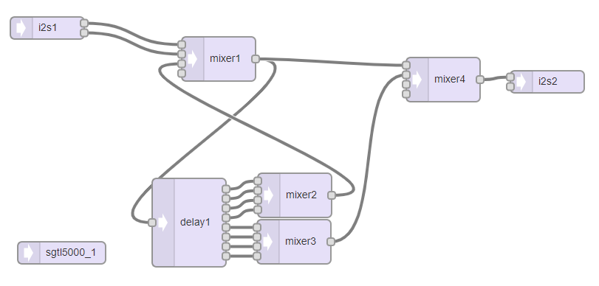
Figure 3.5 Block diagram of reverberation effect

The input from the microphone is given to the mixer1 where right and left channel of the input are added. This signal is delayed using multiple delay tap lines each tap line delaying the signal by different amounts. The amount of delay is controlled by the value obtained from joystick. The first four channels are aggressively attenuated (by values less than 0.5) to prevent exponential constructive interference. The feedback is summed with the original signal and enters the delay for a second time. The process continues until the signal decays. The second four channels of the delay object also represent unique duration delays and are passed directly to the output mixer where original signal is summed. This is given to the output speaker.

3.3 Module 2: Musical Instrument Digital Interface
MIDI is an acronym that stands for Musical Instrument Digital Interface. Technical standard that describes a communications protocol, digital interface and connector that connects a wide variety of electronic musical instruments, computers and related audio devices for playing, editing and recording music [5]. MIDI carries event messages, data that specify the instructions for music, including a note's notation, pitch, velocity, vibrato, panning to the left or right of stereo and clock signals which set tempo.
MIDI input
PC900
Teensy 3.2 with audio shield
MIDI output

Reaper Software

Figure 3.6 Block diagram of a MIDI module.

Reaper digital audio workbench is the software interface used to simulate audio effects induced via the digital push buttons being processed by Teensy 3.2.
Digital Button Configuration:
D0: Note/effect select
D1: Record
D2: Overdub
D3: Half-speed
D4: Sustain Reverse
D5: Stutter
D6: Track select forward
D7: Track select backward

3.4 Module 3: Synthesizer
A synthesizer (often abbreviated to synth) is an electronic musical instrument that generates audio signals that may be converted to sound. Synthesizers may imitate traditional musical instruments or they may be used to generate electronic sounds [6].
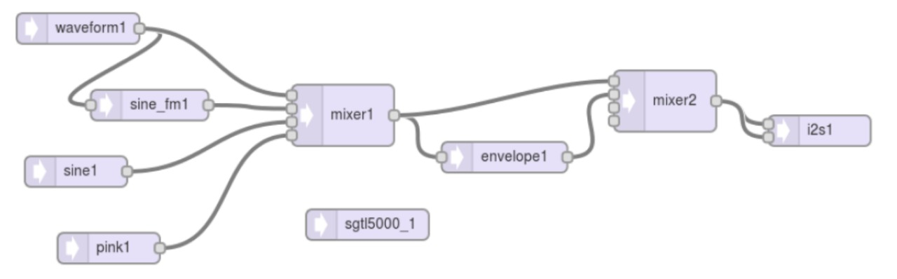
Figure 3.7 Block diagram of the synthesizer module

Hardware Controls:
D0: Cycles through five waveforms- Square, sine, sawtooth, pulse, triangle
D1: Cycles through four of the mixer inputs- Control waveform, frequency modulated sine, pure sine, white noise.
D2: Press- Note begin, Release- Note end
Analog Potentiometers : A2- Varies control waveform frequency, A3- Varies pure sine frequency.

CHAPTER 4
REAL TIME AUDIO SYSTEM TAKING INPUT FROM MICROPHONE

The scope for this module is focused on using Teensy hardware platform in conjunction with Teensy audio shield and audio library to create simple DSP system to produce real time reverberation effect and distortion effect.
The logical design for flow of data in this DSP system consists of 2 layers: Audio system flow and program system flow. The audio system flow is designed by using the Teensy audio library GUI [8]. This defines the functionality of the audio effect. Multiple audio effects can be incorporated into a single code by program system flow according to our requirement. The audio system flow for the distortion and reverberation effects are given in Figure 3.4 and Figure 3.5 respectively.

4.1 Circuit Design
The circuit diagram for this block is made up of 5 primary components:
1) Teensy 3.2 microcontroller board
2) Teensy audio shield
3) Switch
4) 2-axis joystick
5) 10 kilo ohm potentiometer

The Teensy 3.2 and audio shield are responsible for driving all logical operations. There are three human interface devices: A joystick, potentiometer and a selector switch.
The 2-axis joystick functions as a variable resistor to manipulate the audio effect parameters. The joystick also functions as a momentary push button when the joystick 'hat' is pressed directly down. This momentary switch serves as a 'MUTE' toggle switch.
The 10 K potentiometer serves as a volume control knob. The selector switch functions as a switch to choose between Reverberation(left position), Distortion(right position) and pass through(neither of the positions). External pull up resistors are used for the switch functionality.
The schematic for the circuit is shown in Figure 4.1.

3.3v
Teensy 3.2
2
16
17
0 1 21
24
Teensy audio shield
USB

Joystick
sw vrx
vcc
gnd vry
3.3v

3.3v gnd 10K 10K pot

3.3v

Figure 4.1 Circuit diagram of module 1

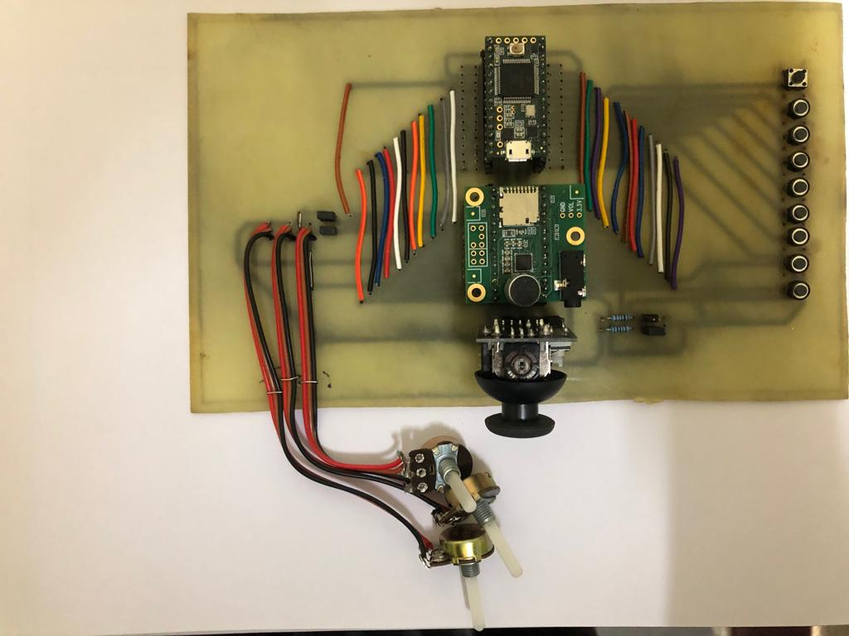

Figure 4.2 Picture of the hardware portion with module 1 highlighted

4.2 Flowchart
Start

Joystick button pressed
Analog read sensors
Digital read sensors

no yes
unmute audio
mute audio

Switch top position
yes
Reverberation effect

no
Switch toggled
yes
Distortion effect

no

Figure 4.3 Flowchart of module 1

4.3 Output
The output of module 1 can be examined by recording the sound and plotting it in 'Scilab' software.
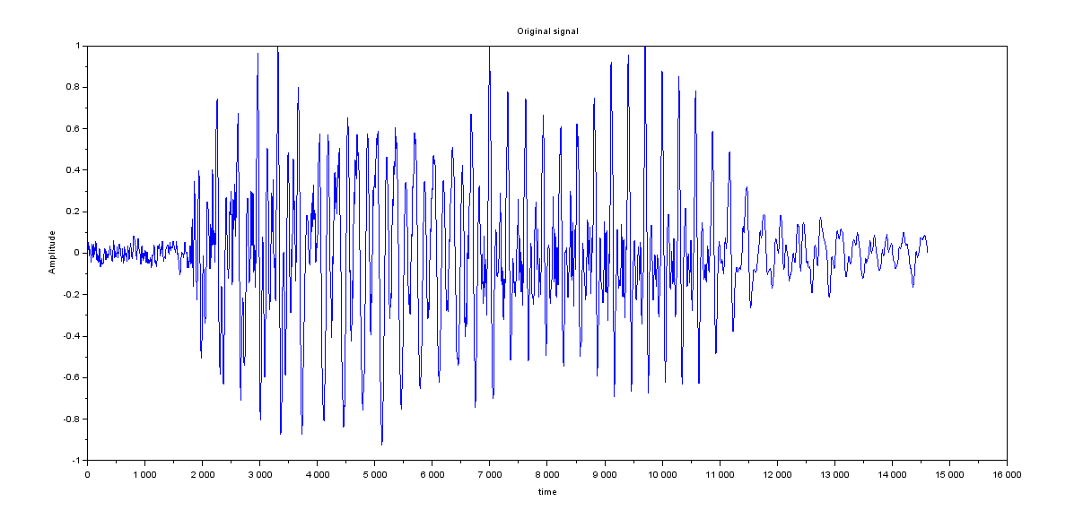
Figure 4.4 Original signal

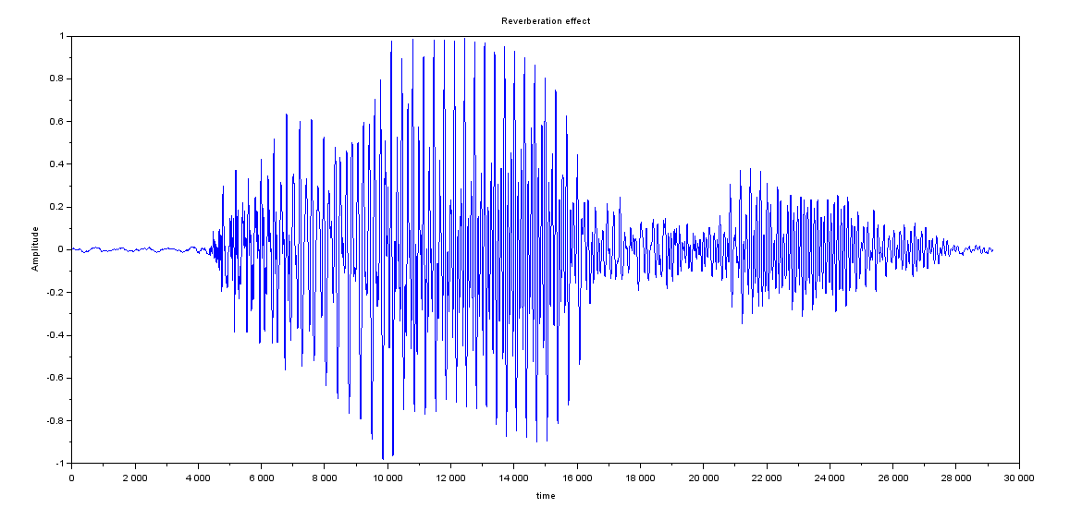
Figure 4.5 Reverberation effect on original signal

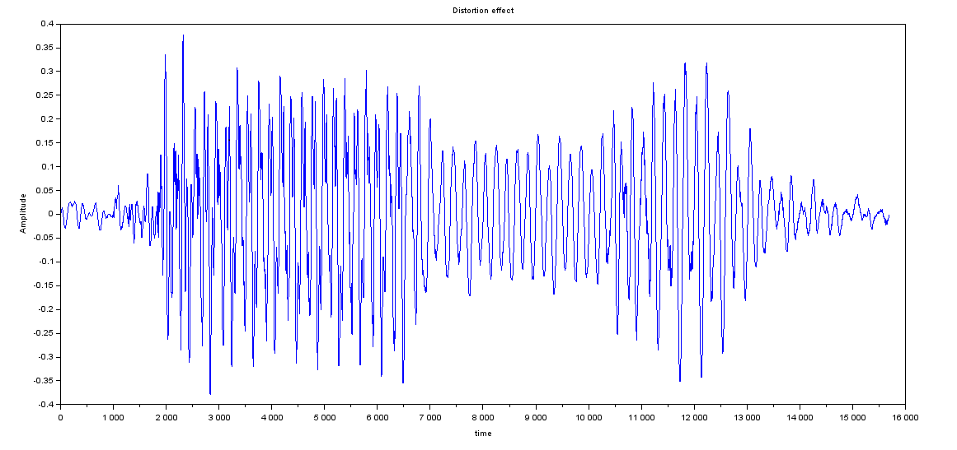
Figure 4.6 Distortion effect on original signal

4.4 Summary
Module 1 takes real time audio input from the microphone on the audio shield and gives back either distortion or reverberation effect instantly based on the position of the switch. The joystick controls the amount of effect.
Figure 4.4 shows the waveform of a person saying 'Hello'. The synthesized waveform with reverberation effect is shown in Figure 4.5. The synthesized multiple reflections which are delayed and attenuated are evidently visible in the highlighted portion of the Figure 4.5.
Figure 4.6 shows the waveform of synthesized distortion effect. It is evident that the top and lower portions of the wave are clipped. This is because of bit crusher block in the Figure 3.4. The least significant bits are made zero. In other words, the waveform is clipped digitally. The sampling rate of the signal is also decreased which adds up to the distortion effect.
Apart from the above discussed effects, other audio effects such as flange, chorus and filters with each of them having their own specific block diagrams which can be converted to audio system flow can also be synthesized. The same code can be used by changing the part of the code which contains audio system flow.

CHAPTER 5
MUSICAL INSTRUMENT DIGITAL INTERFACE (MIDI)

MIDI is an acronym that stands for Musical Instrument Digital Interface. It’s a way to connect devices that make and control sound such as synthesizers, samplers, and computers so that they can communicate with each other, using MIDI messages. This lets one keyboard trigger sounds on another synthesizer, and it makes it possible to record music in a form that allows for easy note editing, flexible orchestration, and song arrangement. Virtual instruments are computer programs that simulate hardware synthesizers and samplers that also communicate with computer sequencing software running on the same computer using MIDI messages. MIDI evolved as a standard to enable communication between the more compact and affordable synthesizers that were available in the early 1980s, after the era of large, expensive modular analog synthesizers. MIDI was meant to allow someone to control multiple synthesizers from a single keyboard, so as to generate, for example, the massive layered sounds popular in some1980s pop music.

5.1 Implementation Using Teensy 3.2
The Teensy-Audio shield interface generally takes I2S input from the microphone or from the in-built SD card. But implementation of MIDI requires the microprocessor to accept response data from push buttons that are de-bounced and connected to the digital pin rack. This flexibility in re-wiring and customization is possible due to the extensive MIDI code library developed by PJRC. MIDI uses the hardware serial ports to communicate with standard MIDI devices at 31250 baud. This is completely separate from, and can be used together with USB MIDI.
The Teensyduino 2.0 library supports the use of USB MIDI configuration for input notes. One of the digital pins (D0 in the project) is set to assume one of two distinct states with the aid of a toggle switch, whose function is to allow MIDI to operate in one of the two preset modes- Effect Inducer and Sample Player. The rest of the digital pins upto D8 function as selection switches for either the sound effects or the pre-recorded audio samples. The processor accepts input (media file) and the choice as well as control parameters of the audio effects from a Digital Audio Workstation (DAW) and the communication of MIDI notes happen using the standard USB protocol. Inputs can be extracted either from a real time musical instrument in concurrence with the module’s name or from a recorded audio sample wherein the effects are induced as and when the MIDI notes are received without any transit delay making it a reliable device for live digital audio processing. A variety of audio effects are available for processing in the 'REAPER DAW' employed in the project that adapt in accordance with dynamic baud rate of MIDI communication.
Teensy 3.2

Digital pin control rack
Reaper DAW
Audio shield

Mobius looper
virtual control board
Waveform analyzer
and output

Figure 5.1 Block Diagram of Teensy MIDI

The mini project incorporates REAPER x64 which can also run 32-bit plug-ins alongside 64-bit processes.
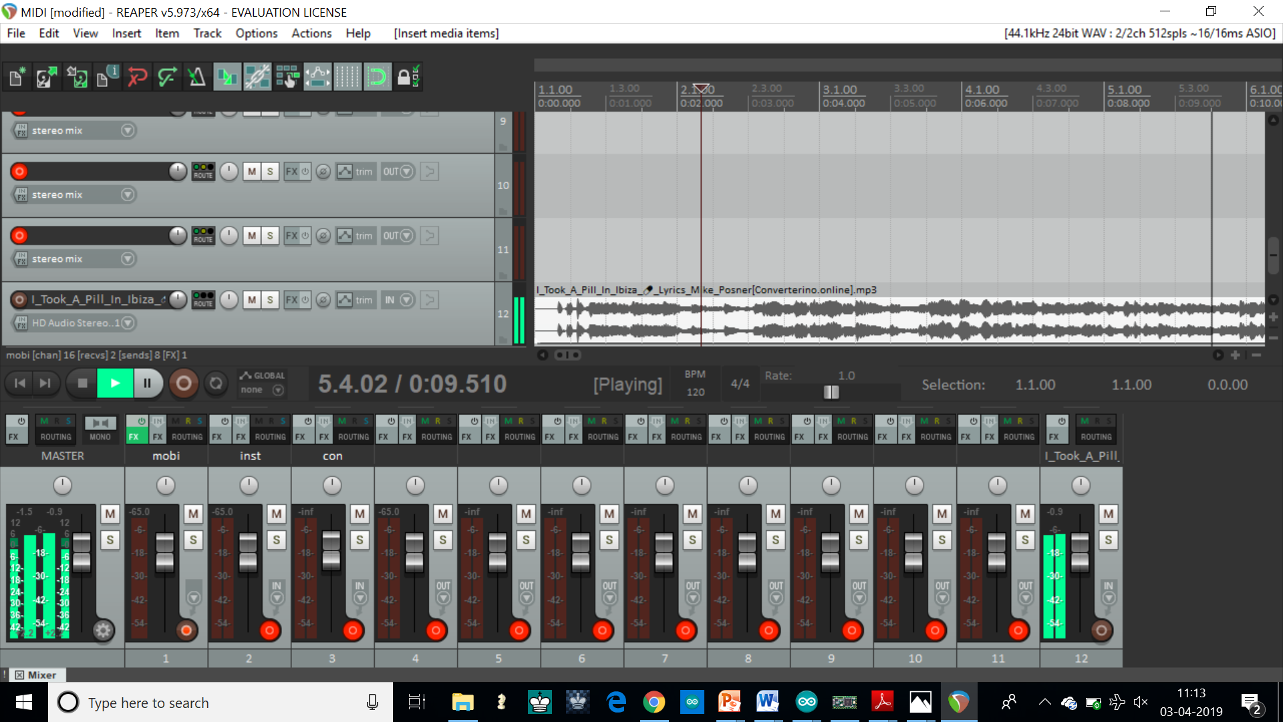
Figure 5.2 REAPER DAW GUI

Mobius is a tool for live recording and manipulation of audio loop. The tool has extensive MIDI and keyboard control to be interfaced with any DAW.

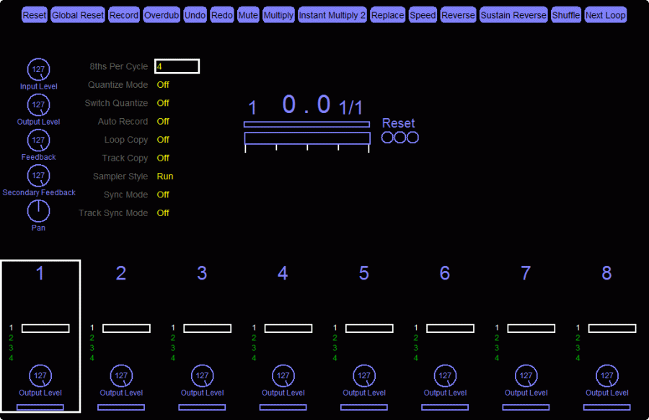
Figure 5.3 Mobius Looper Dashboard

5.2 Output
Following are the effects induced in the designed MIDI module:
Digital Button Configuration:
D0: Note/effect select
A low signal sends sample note whereas a high signal sends an effect note
D1: Record
Records the media sample until the button is released
D2: Overdub
Technique used in audio recording, whereby a musical passage is recorded two or more times. This practice can be found with singers, as well as with instruments, or ensembles/orchestras.
In vocal performances the performer usually listens to an existing recorded performance (usually through headphones in a recording studio) and simultaneously plays a new performance along with it, which is also recorded. The intention is that the final mix will contain a combination of these "dubs".
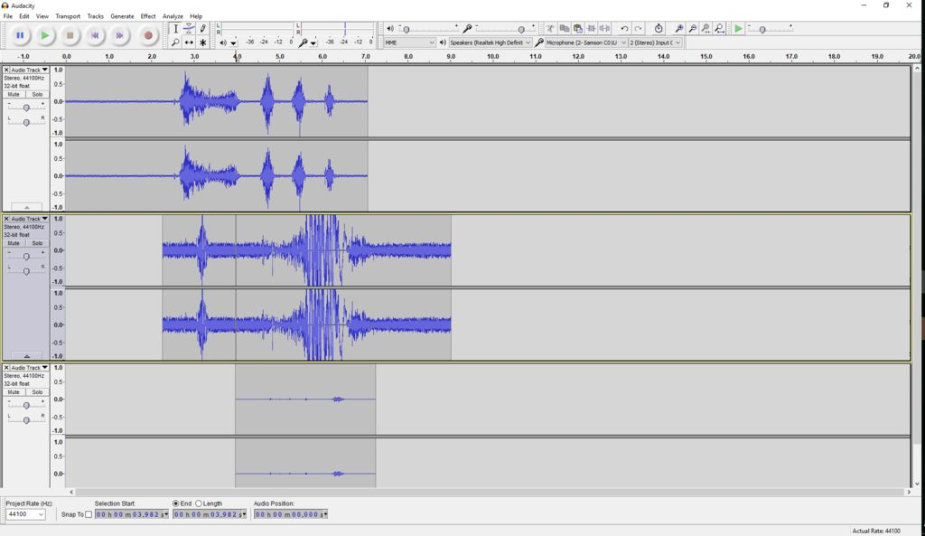
Figure 5.4 Overdub effect waveform
D3: Half-speed
Plays the selected clip at half of its original speed.

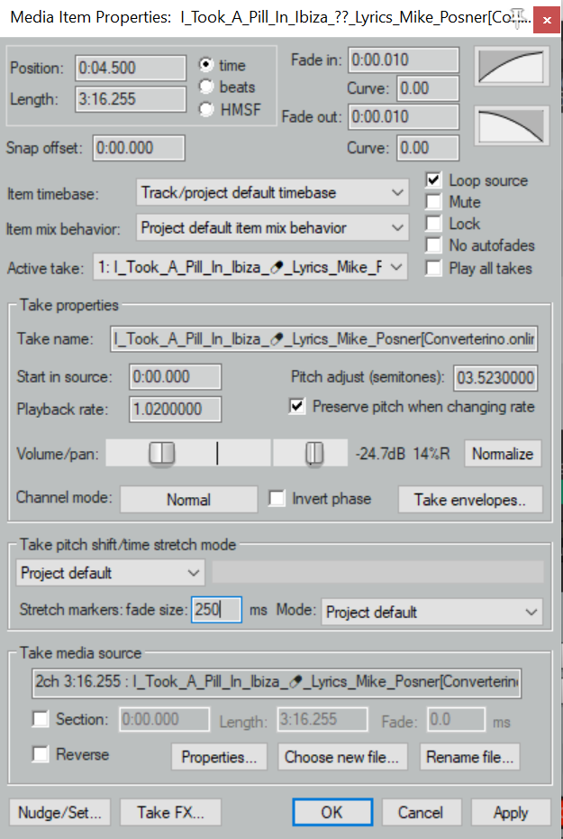
Figure 5.5 Tempo change window in REAPER DAW

D4: Sustain Reverse
Reverses the song bit in the sustain phase of its envelope.
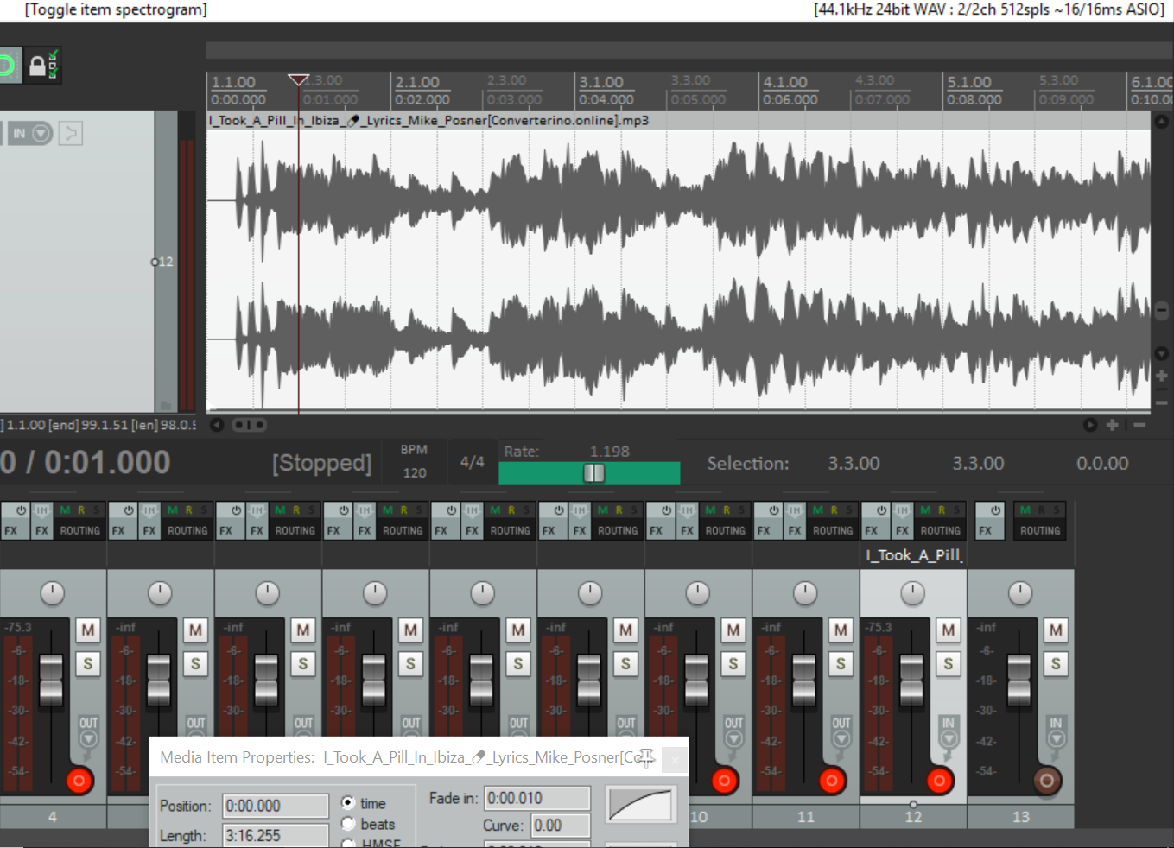
Figure 5.6 Sustain reverse effect
D5: Stutter
Stuttering or glitch, is a vocal effect achieved by chopping audio into a very small section, and then copying and pasting it repeatedly onto a track.
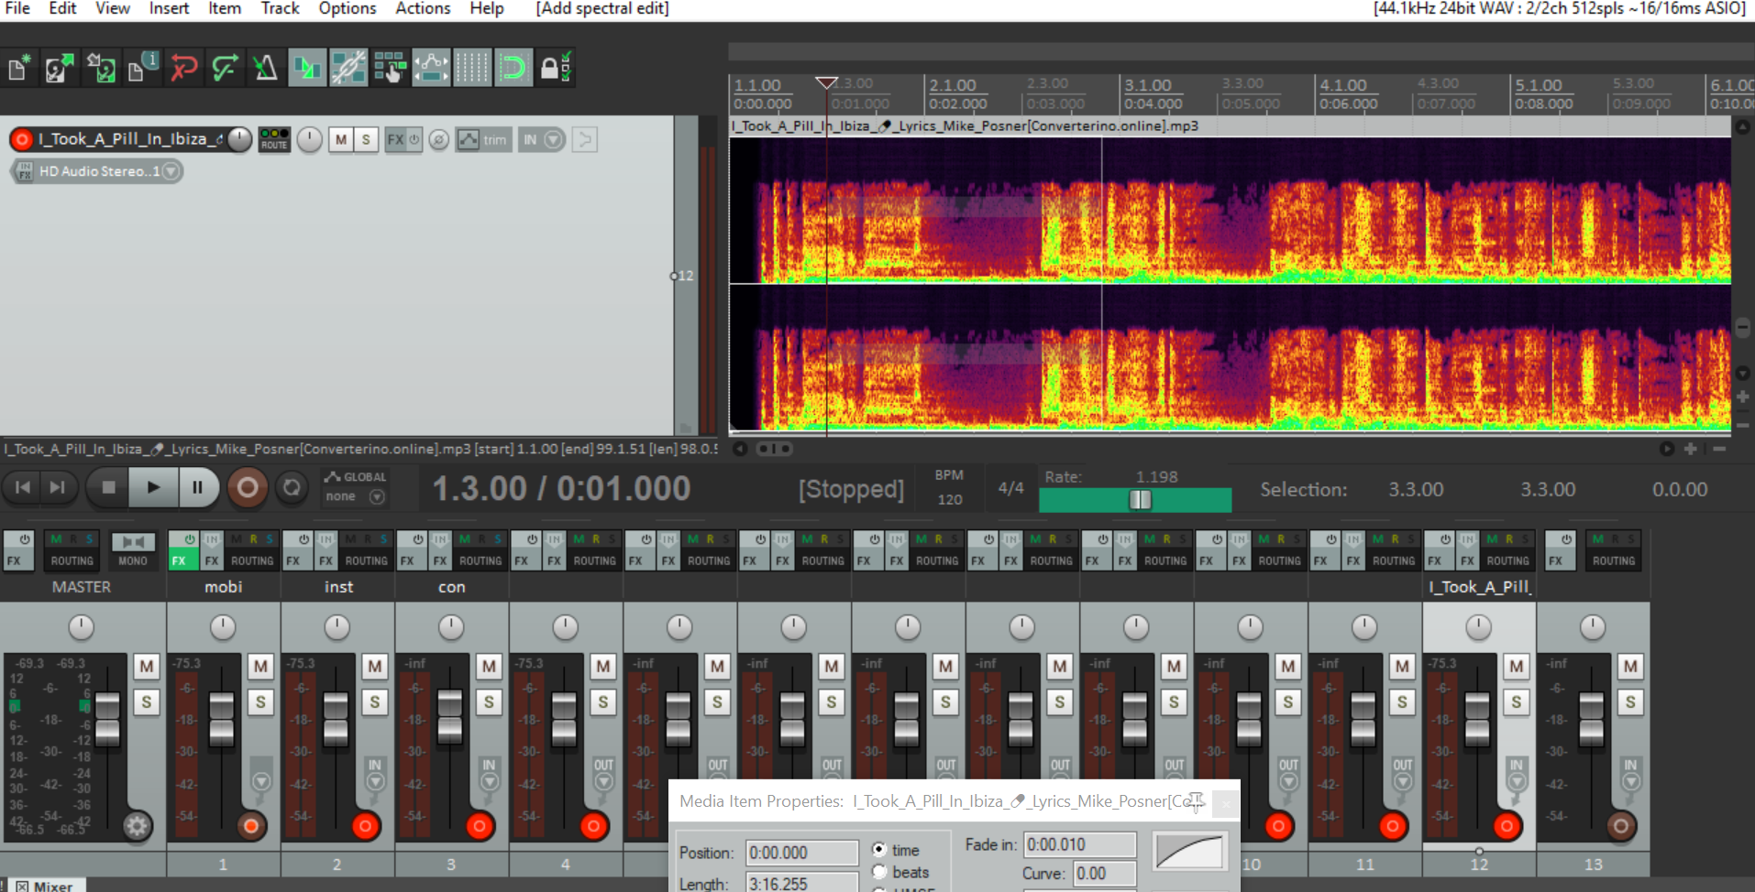
Figure 5.7 Stutter waveform

D6: Track select forward
Selects the next track in Mobius Looper
D7: Track select backward
Selects the previous track in Mobius Looper

5.3 Summary
The MIDI implemented using Teensy could be operated in any desired number of modes such as instrument translation (Simulating sounds of different musical instruments on a single instrument), sample player, DAFx Processor etc., while a variety of other effects can be coded onto a single digital pin whose functionality can be changed by varying the analog value of a continuum-valued switch or potentiometer.
The dynamic nature of protocol used in USB MIDI ensures that the processing happens simultaneously without necessitating a static recording device. The flexibility provided in using different modes of input makes it a great choice for low budget music production with DAFx.

CHAPTER 6
SYNTHESIZER
A synthesizer (often abbreviated to synth) is an electronic musical instrument that generates audio signals that may be converted to sound. Synthesizers may imitate traditional musical instruments such as piano, flute, vocals, or natural sounds such as ocean waves or generate novel electronic timbres. They are often played with a musical keyboard, but they can be controlled via a variety of other devices, including music sequencers, instrument controllers, fingerboards, guitar synthesizers, wind controllers, and electronic drums. Synthesizers without built-in controllers are often called sound modules, and are controlled via USB, MIDI often a MIDI keyboard or other controller [6].
Synthesizers use various methods to generate electronic signals (sounds). Among the most popular waveform synthesis techniques are subtractive synthesis, additive synthesis, wavetable synthesis, frequency modulation synthesis, phase distortion synthesis, physical modeling synthesis and sample-based synthesis.
6.1 Block Diagram
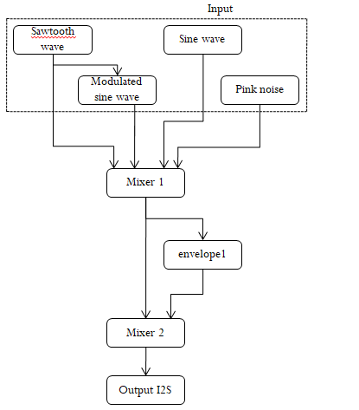
Fig 6.1 Block Diagram of Synthesizer
The input block provides different input signals such as square, sine, sawtooth, triangular, pulse which are fed to mixer 1. This mixer send out one input signal at a time based on the activity of the button D0. The frequency of the waves are controlled using potentiometer A3. The envelope block modifies the input signal with a DAHDSR (Delay Attack Hold Delay Sustain Release) envelope. The amount of effect is varied using potentiometer A2 and the different effects are varied using button D1. The final mixer feeds the output sound effect to the speaker.
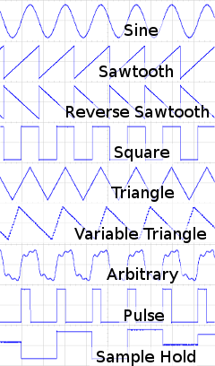

Fig 6.2 Supported input waveforms

6.2 Flowchart
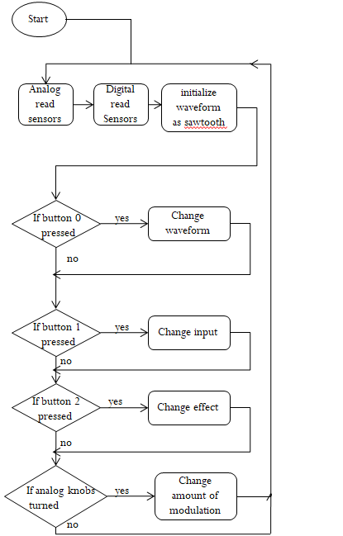
Fig 6.3 Flow Chart of Synthesizer module

6.3 Hardware Controls
D0: Cycles through five waveforms- Square, sine, sawtooth, pulse, triangle
D1: Cycles through four of the mixer inputs- Control waveform, frequency modulated sine, pure sine, white noise.
D2: Press- Note begin, Release- Note end
Analog Potentiometers : A2- Varies control waveform frequency, A3- Varies pure sine frequency.
6.4 Output
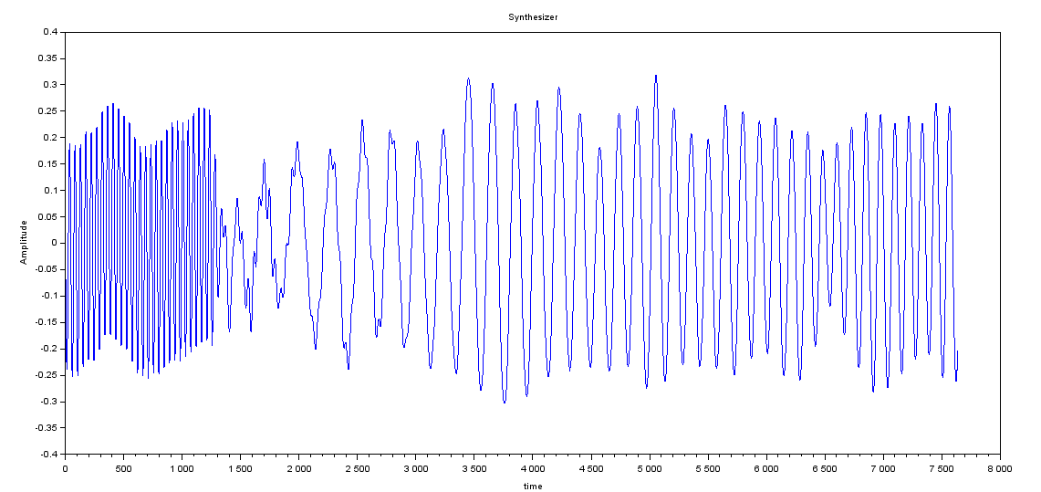
Figure 6.4 Synthesizer output
Figure 6.4 shows the modulation of the input sinusoidal waveform by the envelope block. It is evident that the frequency of the signal is being changed to create different textures of the produced output sound. All this is being done digitally.

6.5 Summary
The synthesizer implemented in the mini project demonstrates how changing the shape of sound envelope has a great effect on the control of waveforms as well as their tonality. Contrary to the operation of MIDI or any other DAFx unit that accepts real time audio signals either from microphone (I2S Interfaced) or the SD card unit in Audio Shield, the synthesizer generates electronic signals by mixing pure sine wave, modulated sine wave, pink noise in accordance with the envelope of control waveform, in a particular manner and then induces an intentional distortion in the generated signal’s envelope to essentially created electronic audio effects.

CHAPTER 7
CONCLUSION

The project gives a clear insight into the audio processing using Teensy 3.2. This system is capable of reading-in analog audio signals in, converting the analog audio signal into digital data, applying “effect” transformations in “real-time” with unperceivable latency, and outputting the modulated audio signal to an analog device.
The audio system described in this experiment is adequate to process line-level audio with minimal system latency. However, such a system is inefficient for use on a larger-scale. Lack of available RAM significantly limits the system capability in how much audio-information can be dynamically stored. However, for applications that do not require delaying signals, the Teensy 3.2 and Audio Shield, given the 16-bit 44.1 kHz audio quality, are extremely versatile tools for developing high resolution, prototype DSP-systems at low cost.

REFERENCES
[1] M. Pfaff, D. Malzner, J. Seifert, J. Traxler, H. Weber, G. Wiendl, “Implementing Digital Audio Effects Using a Hardware/Software Co-Design Approach”, Proc. of the 10th Int.Conference on Digital Audio Effects (DAFx-07), Bordeaux, France, September 10-15, 2007.

[2] D. Campbell, G. Cunningham, C. Lozinsky, R. Schultz, “FPGA Implementation of Audio Effects - An EE 552 Student Application Note”, University Of Alberta – 2003.

[3] A. Baghaki, “Single-Microphone Speech De-reverberation based on Multiple-Step Linear Predictive Inverse Filtering and Spectral Subtraction”, Master’s Thesis, Concordia University, Canada –August 2013.

[4] R R Prasad, M Dinakaran “Single Channel Speech De-reverberation For Acoustic Signals” , Master’s Thesis, Blekinge Institute of Technology, December 2012.

[5] Introduction to MIDI and Computer Music: The MIDI Standard, http://www.indiana.edu/~emusic/361/midi.htm, Accessed on 10 February 2019.

[6] David Crombie (The complete synthesizer: a comprehensive guide), https://exellon.net/book/The_Complete_Synthesizer.pdf, Accessed on 19 February 2019.

[7] Microcontroller audio workshop and HaD supercon 2015, https://hackaday.io/project/8292-microcontroller-audio-workshop-had-supercon-2015, Accessed on 25 February 2019.

[8] Audio system design tool for Teensy audio library, https://www.pjrc.com/teensy/gui/index.html?info=AudioInputI2S, Accessed on 03 March 2019.

[9] Audio tutorial kit, https://www.pjrc.com/store/audio_tutorial_kit.html, Accessed on 04 March 2019.

APPENDIX
Teensy 3.2 pin out:
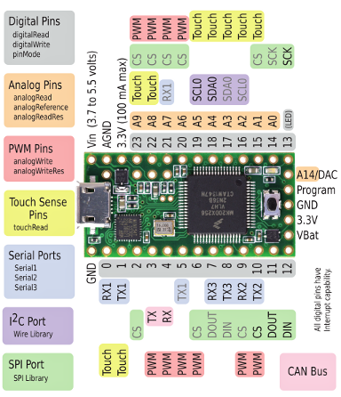
Front side
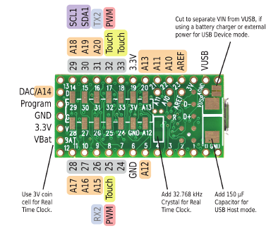
Back side

